

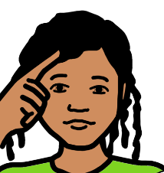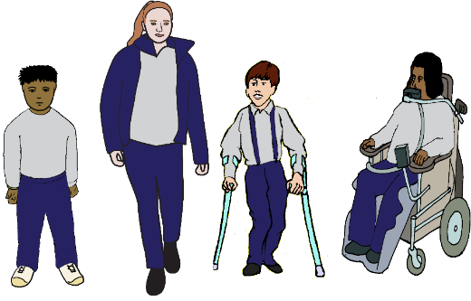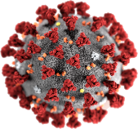

**Think about**

**COVID 19 and school.**

**Questions for students.**

The Australian Government has some things

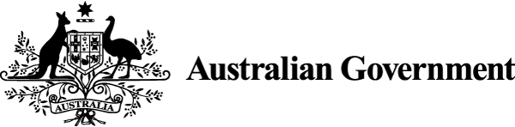

for you to think about.

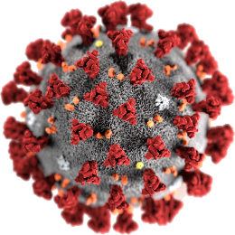

We want to know about

* COVID 19

**and**

* A picture containing text

  Description automatically generatedschool children with disabilities.

We call you students.

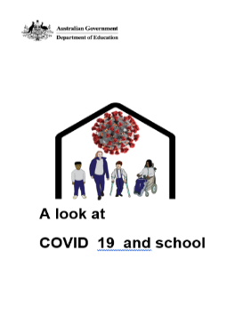

Read **A look at COVID 19 and school**.

We want to hear from

* students with disabilities
* 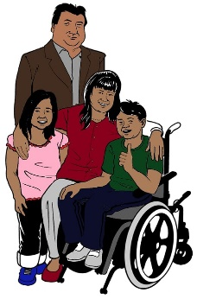family
* people who care for you.

Think about these things.

**Then**

Tell us your story.

You do **not** have to talk about each thing.

**Things to think about**

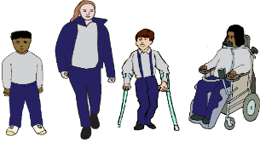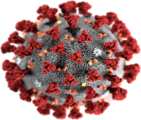

For school and COVID 19.



How did your school help you? What was good?

How much help did you get

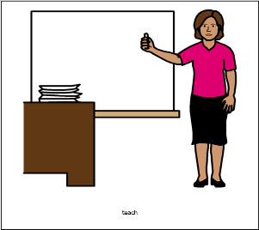

* from your teacher?
* from other teachers?

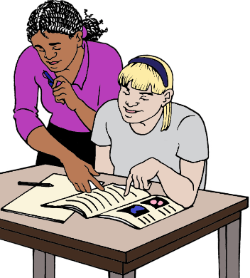What about the other people who help you

at school? Like

* a person who helps you read
* a person signs in class
* a therapist.

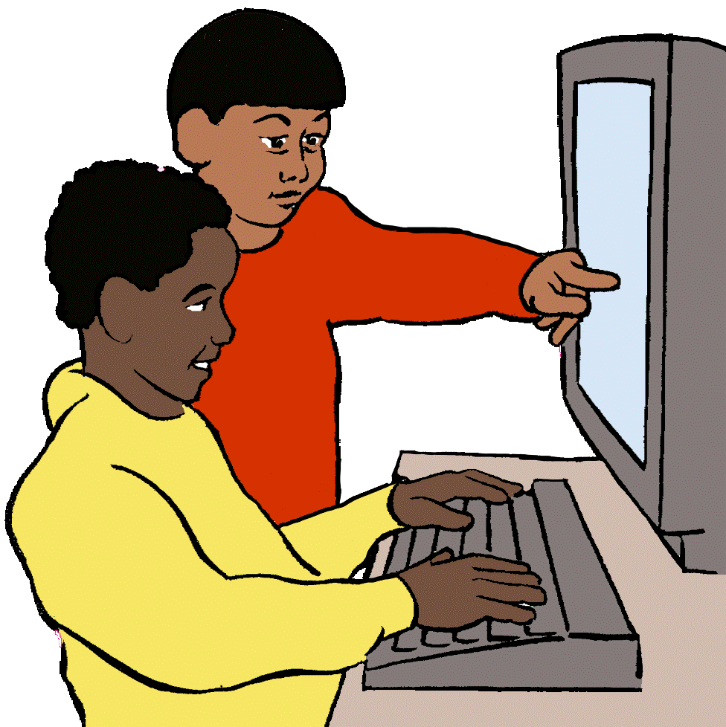

You were home with your family.

What was it like?

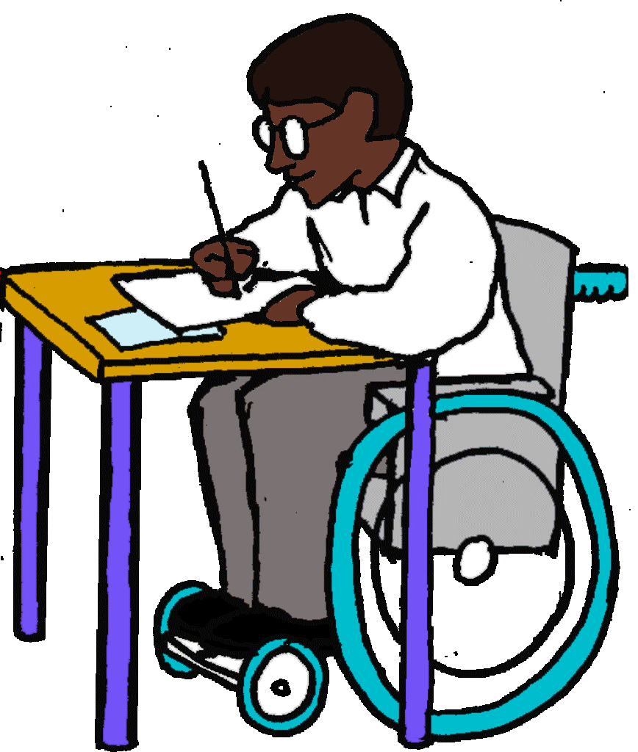

Did you have a place to do your school work?

Did your parents know how to help you?

Did you still learn?

Did you get school work?

Was your work in different ways? Like you had

* to learn by yourself
* do games with your family
* watch videos.

Did you have the things you need

to learn at home? Like

* a computer
* headphones
* internet.

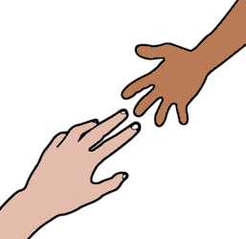

Did you know how to use these things?

Did you get help?

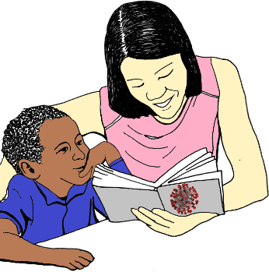Did you get help about how you felt? Like

* you were scared about COVID 19
* you worried about school.

Did you have a person to talk to?

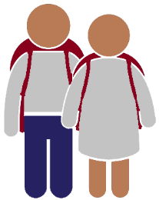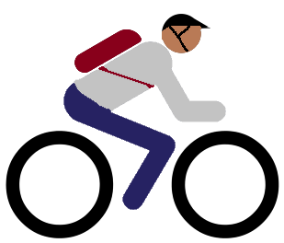

**You went back to school**

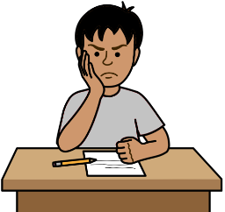

What made it hard for you?

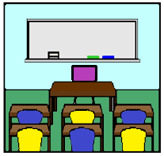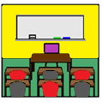

Were you ready to move to the next year

at school? Like you finish year 3.

You need to move to year 4.

Were you ready to change your school?

Like you are in year 6. You move to year 7.

It is at a different school.

Were you ready to finish school?

Now you go to

* TAFE
* a job.

What about your friends?

**Schools need to shut some times**

It may be for

* COVID 19

**or**

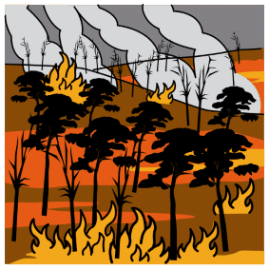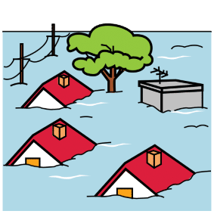

* bush fires
* floods.



What can schools do better?

**You want to know more**

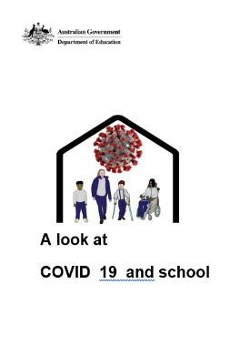

Read **A look at** **COVID 19 and school**.

You want help to tell your story.

The Social Deck can help you.

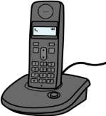

Call 0491 617 118

These ideas are from the Australian Government Department of Education discussion paper.

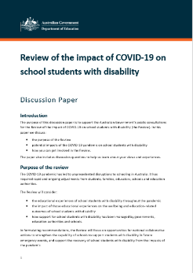

Review of the impact of COVID - 19 on

school students with disability. October 2022.

Images

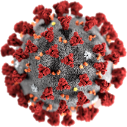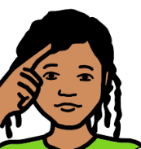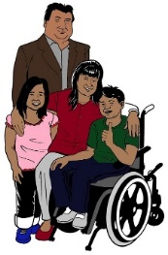

We can use these images

* ChangePeople
* InspiredServices
* Freepikpsd com
* Picto-Selector
* TheNounProject
* Tobii-Dynavox.

We can use the logos.

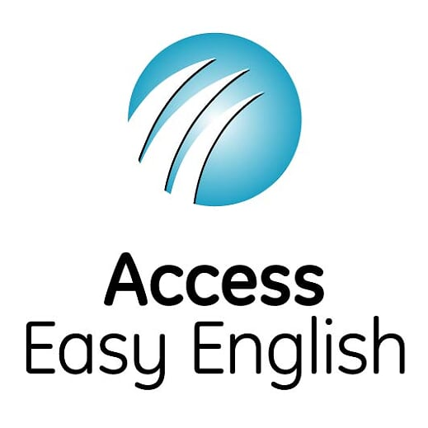Access Easy English wrote the Easy English. October 2022.