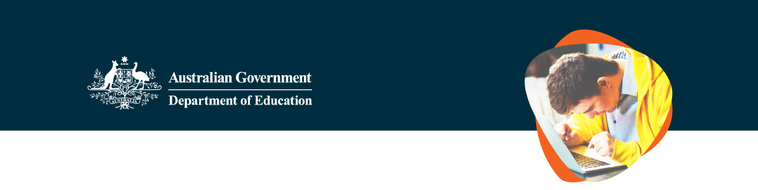
Review of the impact of COVID-19 on school students with disability
The Australian Government is talking to students, parents, carers and educators to do a Review of the impact of COVID-19 on school students with disability.
The Review is looking at the school and learning experiences for students with disability during the pandemic and how students have been impacted.

What the Review will cover
We know the COVID-19 pandemic impacted school students with disability in many different ways.
This review will provide advice to:
help us better understand those impacts on students with disability
look at ways to support the recovery of school students with disability from the impacts of the pandemic
plan how governments and schools can support students with disability in future events like this.
We need to hear directly from school students with disability, and their families or carers, about their experiences with education during the pandemic.

What we want to find out
We want you to tell us about your or your child’s education experiences during the pandemic. We want to know how COVID-19 has impacted school students’:
learning | wellbeing | support.

- Key questions | We want to know things like:
What changed for you during COVID in terms of school and learning?
How well did schools and governments support you to continue learning during the COVID pandemic?
How well connected did you feel to your school, teachers, friends or peers during the COVID pandemic?
How did changes to education impact your ability to do school work and learn?
How did changes to education affect your mental health and wellbeing?
What do you think could be done better for students with disability if another emergency like the COVID-19 pandemic happens in the future?

How to get involved
You can get involved in the Review by visiting disabilitycovidreview.education.gov.au
There are lots of different ways to get involved and share your experiences and ideas.
Register for the webinar  (online event) | Register your interest in attending a focus group | Register your interest to participate in an online written discussion board
This is for current and recent school students, and their parents or carers. It is an online event that will go for 1.5 hours where you can find out more about the Review and have your say using an online engagement tool. | These are sessions that will run for up to 2 hours where you can talk in a group with up to 10 other students, or parents/carers, about your experiences and what would have helped you during the COVID pandemic.  Most focus groups are held online. | These boards are held on Microsoft Teams and they allow you to chat and share your experiences in writing with other students or parents/carers.  We ask you a series of questions over three days. You can respond to the questions during this period when it best suits you.
There are also other ways you can get involved. You can:
- complete one of the online surveys
- send a written, video or audio story (submission)
- request a one-on-one discussion to share your experiences
(by emailing The Social Deck at engage@thesocialdeck.com)
Express your interest to join the Young Person’s Advisory Group
If you are a current school student, or were a school student in 2020, 2021 or 2022, you can express your interest to join the Department of Education’s Young Person’s Advisory Group. As part of this group you will help the department to work on this Review.
You can Express Your Interest using this form.

Support and accessibility
All of our events are accessible. We have Easy Read information available, and there will be Auslan interpreters and live captioning available at events, which you can request when you register.
Please get in touch with The Social Deck team at the details below if you require any support to register for an event or when you are planning to attend an event.

Contacts
If you want to get involved in the Review or need help to prepare for an event, you can contact
The Social Deck at engage@thesocialdeck.com or on 0491 617 118.
If you want to know more information about why this Review is being done, you can contact the Department of Education at DisabilityStrategy@education.gov.au.

